PRIPREMA ZA IV. PISMENI ISPIT ZNANJA – I. DIO
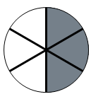
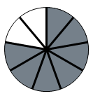
- Koliki je dio lika osjenčan:
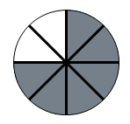
a. b. c.

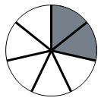
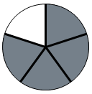
d. e.

- Nadopuni:
  - $\frac{2}{5}m=\text{_________}\text{cm}$
  - $\frac{3}{4}\text{dm}=\text{________}\text{mm}$
  - $\frac{1}{2}a=\text{_________}m^{2}$
  - $\frac{1}{\text{20}}{\text{km}}^{2}=\text{________}\text{ha}$
  - ${\left(\frac{2}{3}\right)}^{°}=\text{________'}$
  - $$\frac{7}{\text{10}}l=\text{______}\text{dl}$$
- Koliko je:
  - $\frac{2}{3}$ od broja 4152;
  - $\frac{4}{7}$ od broja 2275?
- Zbroji:
  - $$\frac{1}{\text{11}}+\frac{4}{\text{11}}=$$
  - $$\frac{3}{7}+\frac{4}{7}=$$
  - $$\frac{7}{9}+\frac{3}{9}=$$
  - $$\frac{4}{5}+\frac{6}{5}=$$
- Oduzmi:
  - $$\frac{\text{11}}{7}−\frac{3}{7}=$$
  - $$\frac{\text{135}}{4}−\frac{\text{15}}{4}=$$
- Izračunaj:
  - $$\left(1−\frac{1}{4}\right)−\left(\frac{3}{4}−\frac{1}{4}\right)=$$
  - $$\frac{1}{2}+1−\frac{3}{2}=$$
  - $$\frac{\text{12}}{5}+\frac{4}{5}−\frac{1}{5}=$$
  - $$\frac{\text{362}}{\text{27}}−\frac{\text{145}}{\text{27}}=$$
  - $$\frac{\text{5627}}{\text{36}}−\frac{\text{4321}}{\text{36}}=$$
- Zapiši u obliku mješovitog broja:
  - $$\frac{\text{16}}{7}$$
  - $$\frac{\text{374}}{\text{15}}$$
  - $$\frac{\text{154}}{3}$$
- Koje prirodne brojeve možeš staviti umjesto x pa da vrijedi:
  - $$\frac{1}{7}≤\frac{x}{7}<\frac{5}{7}$$
  - $$\frac{x}{4}≤\frac{3}{4}$$
  - $$\frac{5}{\text{11}}<\frac{x}{\text{11}}≤\frac{\text{10}}{\text{11}}$$

